Lab Sheet 4: **Java Servlet**

**Simple Servlet - Display Static Message**

1. Create a Java Servlet (DisplayMessageServlet) that outputs a static message.
2. Configure the servlet using the @WebServlet annotation or the web.xml deployment

Descriptor

import java.io.IOException;

import java.io.PrintWriter;

import javax.servlet.ServletException;

import javax.servlet.http.HttpServlet;

import javax.servlet.http.HttpServletRequest;

import javax.servlet.http.HttpServletResponse;

public class DisplayMessageServlet extends HttpServlet {

protected void processRequest(HttpServletRequest request, HttpServletResponse response)

throws ServletException, IOException {

response.setContentType("text/html;charset=UTF-8");

try (PrintWriter out = response.getWriter()) {

/* TODO output your page here. You may use following sample code. */

out.println("<!DOCTYPE html>");

out.println("<html>");

out.println("<head>");

out.println("<title>Servlet DisplayMessageServlet</title>");

out.println("</head>");

out.println("<body>");

out.println("<h1>Welcome to the Java Servlet Lab!</h1>");

out.println("</body>");

out.println("</html>");

}

}

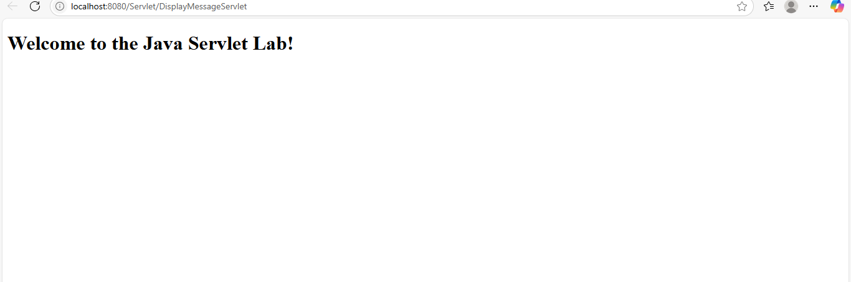

**Get User Input from Form and Display**

1. Create an HTML form to collect the user's name.
2. Create a Servlet (GetUserInputServlet) to handle the form submission and display the user's name.

**HTML Form (index.html)**

<!DOCTYPE html>

<html>

<head><title>Input Form</title></head>

<body>

<form action="getUserInput" method="POST">

Name: <input type="text" name="username" required><br>

<input type="submit" value="Submit">

</form>

</body>

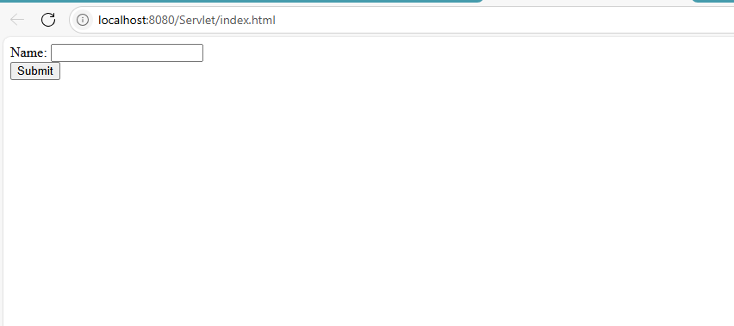</html>

**Servlet Code (GetUserInputServlet.java)**

import java.io.IOException;

import java.io.PrintWriter;

import javax.servlet.ServletException;

import javax.servlet.annotation.WebServlet;

import javax.servlet.http.HttpServlet;

import javax.servlet.http.HttpServletRequest;

import javax.servlet.http.HttpServletResponse;

@WebServlet(urlPatterns = {"/getUserInput"})

public class GetUserInputServlet extends HttpServlet {

protected void processRequest(HttpServletRequest request, HttpServletResponse response)

throws ServletException, IOException {

response.setContentType("text/html;charset=UTF-8");

try (PrintWriter out = response.getWriter()) {

/* TODO output your page here. You may use following sample code. */

String username = request.getParameter("username");

out.println("<!DOCTYPE html>");

out.println("<html>");

out.println("<head>");

out.println("<title>Servlet GetUserInputServlet</title>");

out.println("</head>");

out.println("<body>");

out.println("<h1>Hello, " + username + "!</h1>");

out.println("</body>");

out.println("</html>");

}

}

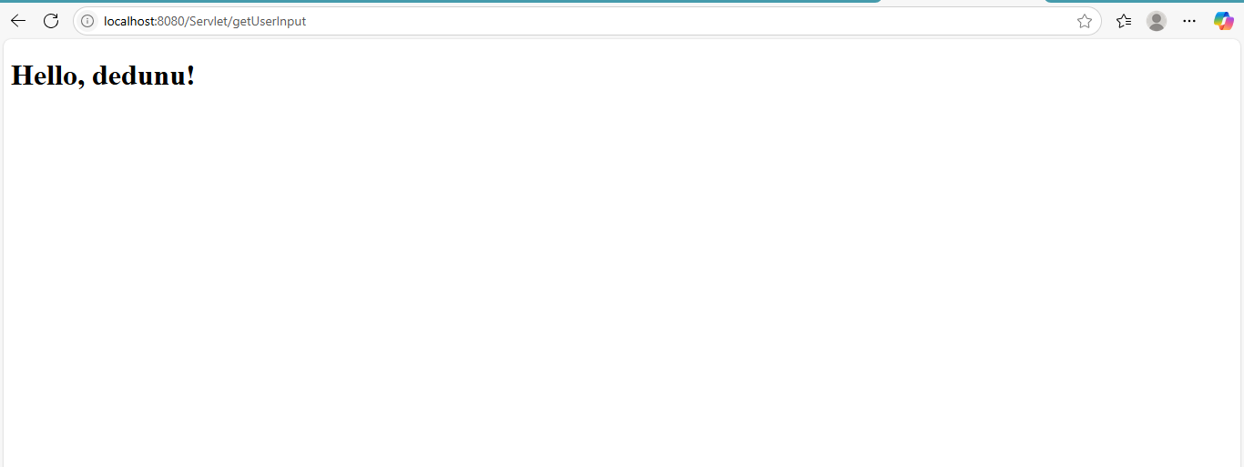

**Get Multiple Inputs, Perform Calculation, and Display Result**

1. Create an HTML form to take inputs for two numbers.
2. Create a Servlet (CalculateSumServlet) to calculate the sum of the numbers and display the result.

**HTML Form (calculate.html)**

<!DOCTYPE html>

<html>

<head><title>Sum Calculator</title></head>

<body>

<form action="calculateSum" method="POST">

First Number: <input type="number" name="num1" required><br>

Second Number: <input type="number" name="num2" required><br>

<input type="submit" value="Calculate Sum">

</form>

</body>

</html>

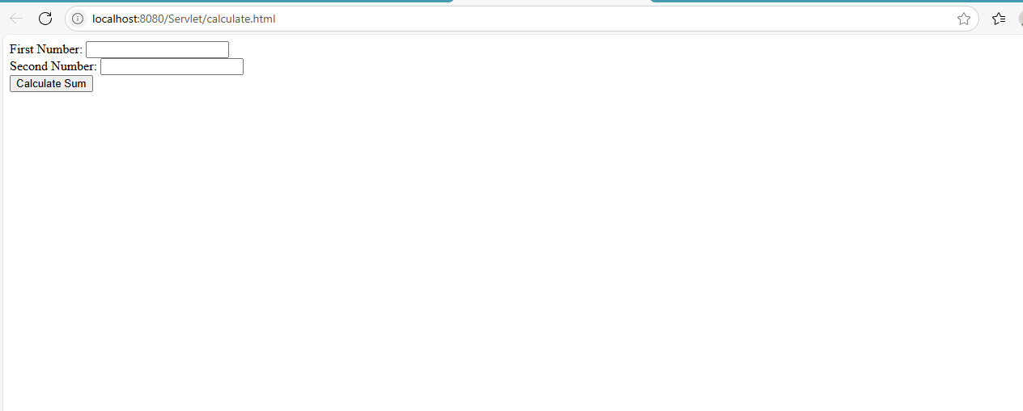

**Servlet Code (CalculateSumServlet.java)**

import java.io.IOException;

import java.io.PrintWriter;

import javax.servlet.ServletException;

import javax.servlet.annotation.WebServlet;

import javax.servlet.http.HttpServlet;

import javax.servlet.http.HttpServletRequest;

import javax.servlet.http.HttpServletResponse;

@WebServlet(urlPatterns = {"/calculateSum"})

public class CalculateSumServlet extends HttpServlet {

protected void processRequest(HttpServletRequest request, HttpServletResponse response)

throws ServletException, IOException {

response.setContentType("text/html;charset=UTF-8");

try (PrintWriter out = response.getWriter()) {

int num1 = Integer.parseInt(request.getParameter("num1"));

int num2 = Integer.parseInt(request.getParameter("num2"));

int sum = num1 + num2;

out.println("<!DOCTYPE html>");

out.println("<html>");

out.println("<head>");

out.println("<title>Servlet CalculateSumServlet</title>");

out.println("</head>");

out.println("<body>");

out.println("<html><body>");

out.println("<h1>The sum of " + num1 + " and " + num2 + " is: " + sum + "</h1>");

out.println("</body>");

out.println("</html>");

 